**Demonstrate implementation of Query Methods feature of Spring Data JPA**

**1. Find countries containing given text**

**Query Method**

List<Country> findByNameContaining(String text);

**Example Usage in OrmLearnApplication**

@Autowired

private CountryRepository countryRepository;

private static void testFindByNameContaining() {

LOGGER.info("Start");

List<Country> countries = countryRepository.findByNameContaining("ou");

countries.forEach(c -> LOGGER.debug("Country: {}", c));

LOGGER.info("End");

}

**Output**

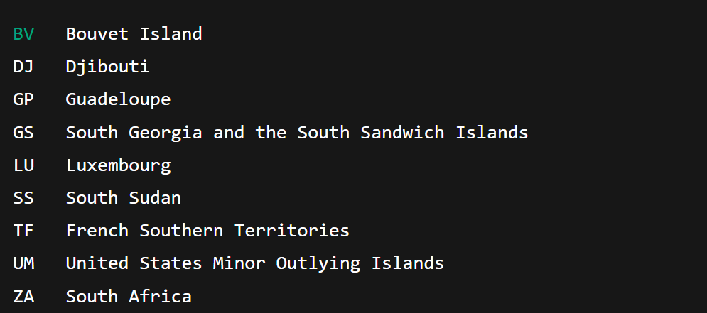

**2. Find countries containing text and sort ascending**

**Query Method**

List<Country> findByNameContainingOrderByNameAsc(String text);



**3. Find countries starting with a specific alphabet**

**Query Method**

List<Country> findByNameStartingWith(String prefix);

**Example**

countryRepository.findByNameStartingWith("Z");

